Project Planning Phase

**Project Planning Template ( Product Backlog, Sprint Planning, Stories, Story Points )**

|  |  |
| --- | --- |
| Date | 31 October 2022 |
| Team ID | PNT2022TMID39010 |
| Project Name | Signs with Smart Connectivity For BetterRoad Safety |
| Marks | 8 Marks |

**Product Backlog, Sprint Schedule, and Estimation (4 Marks)**

Use the below template to create product backlog and sprint schedule

|  |  |  |  |  |  |
| --- | --- | --- | --- | --- | --- |
| **Sprint** | **Functional Requirement (Epic)** | **User Story/Task** | **Story Points** | **Priority** | **Team Members** |
| Sprint-1 | Intializing the Resources | Create an account in OpenWeather API | 1 | LOW | V.Iniyavan S.Nivas  G.Duraishanmugam M.kalaivanan |
| Sprint-1 | Code in Software is written | Write a python script using the inputs given from OpenWeather API | 2 | MEDIUM | V.Iniyavan S.Nivas  G.Duraishanmugam M.kalaivanan |
| Sprint-2 | Sending the software to cloud | The python code from sprint 1 should be sent to cloud so that it is easily accessible | 1 | MEDIUM | V.Iniyavan S.Nivas  G.Duraishanmugam M.kalaivanan |
| Sprint-3 | Initialising the connection between hardware and cloud | The hardware should be intergrated for the easy access of the cloud functions | 2 | HIGH | V.Iniyavan S.Nivas  G.Duraishanmugam M.kalaivanan |
| Sprint-4 | User input-output optimisation and error identification and rectification | Rectify all the shortcomings/errors and initiate the optimisation for better usage | 3 | HIGH | V.Iniyavan S.Nivas  G.Duraishanmugam M.kalaivanan |

**Project Tracker, Velocity & Burndown Chart:( 4 Marks)**

|  |  |  |  |  |  |  |
| --- | --- | --- | --- | --- | --- | --- |
| Sprint | Total Story Points | Duration | Sprint Start Date | Sprint End Date (Planned) | Story Points Completed (as on Planned END Date) | Sprint Release Date(Actual) |
| Sprint-1 | 20 | 6days | 26 Oct 2022 | 31 Oct 2022 | 20 | 31 Oct 2022 |
| Sprint-2 | 20 | 6days | 1 Nov 2022 | 6 Nov 2022 | 20 | 1 Nov 2022 |
| Sprint-3 | 20 | 6days | 8 Nov 2022 | 13 Nov 2022 | 20 | 8 Nov 2022 |
| Sprint-4 | 20 | 6days | 14 Nov 2022 | 19 Nov 2022 | 20 | 14 Nov 2022 |

# Velocity :

The average velocity(AV) per iteration unit (story points per day) can be defined as sprint duration by velocity (points per sprint)

AV= Sprint duration**/**Velocity

***Given:***

Sprint duration= 6days Velocity= 20

AV = 20/6

= 3.33

AV = 3.33

# Burndown chart:

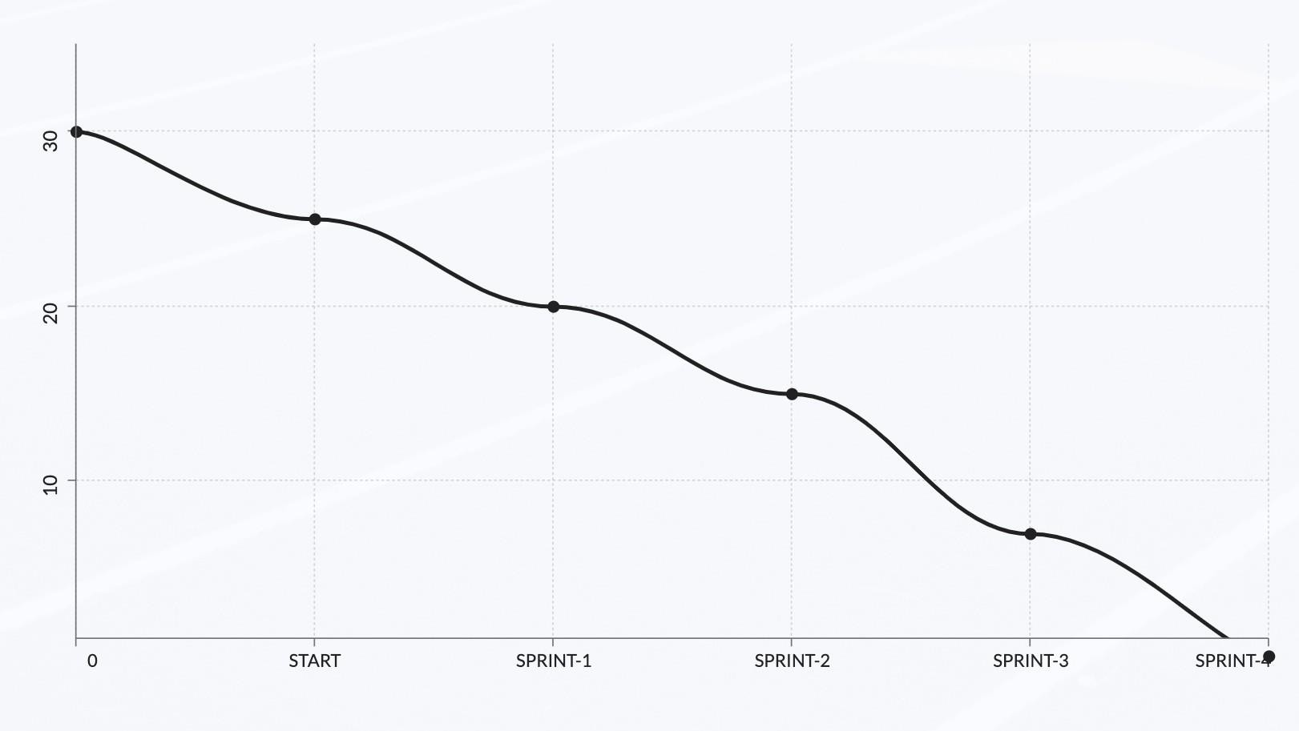

100

50

25

Sprint

Work Remaining